Academics in the Alps 2025 Scholarship Application
Following Jesus—
Virtue, Character, and Truth in the Academy
August 25-28, 2025
Credo House, Wilderswil, Switzerland

There are a limited number of partial scholarships available for applicants from Central and Eastern Europe and some countries in southern Europe.

Scholarship recipients are fully responsible for their travel to and from the conference site and fully responsible for obtaining visas and other travel documents.

Scholarship applications are reviewed in light of the history and quality of the applicant’s roles and commitments within the academy.

Factors considered for the scholarship:
- Is the applicant a follower of Jesus? If not, there is no need to register or apply for a scholarship.
- Is the applicant in an academic role currently, studying as a postgraduate student, or planning to work in an academic role for the next several years?
- Does the applicant need financial help to participate in the conference?
- Is the applicant involved with a local church?
- What are ways the scholarship will help the applicant be a better academic?
- Is the applicant fluent in English?
- Does the applicant reside and work in Europe?

T﻿o be eligible for a scholarship, you must submit a scholarship application to conference@leadershipanvil.org.

Full Name_____________________________________________________________________

Email________________________________Phone____________________________________

Country of Residence___________________ Country of Citizenship______________________

Core Requirements
- English will be the language used in all the sessions. I speak and understand English well enough to participate in a discussion or follow a lecture.
- Yes
- No

- I am a follower of Jesus, and I believe the Bible is the inspired and fully trustworthy Word of God. If your answer is not yes, then your application will not be considered.
- Yes
- No

- I will take full responsibility for obtaining visas and other travel documents and for all my travel costs to and from the conference.
- Yes
- No

- I will arrive at Credo House by at least 7 pm, August 25, 2025 and will not leave the conference site until after lunch on August 28. I will attend all conference sessions.
Scholarship recipients are expected to attend all the conference sessions. Any failure to arrive on schedule or to attend sessions will require repayment of the scholarship funds.
- Yes
- No

- I reside and work in Europe.
- Yes
- No

Describe Your Academic Work and Your Engagement with the Church
If you are approved, you will have to repeat some of these answers on the form when you register.

- What are your primary academic fields?

- Describe your current academic position.

- List your graduate and postgraduate degrees, including institution, year, and field for each degree.

- List the various academic positions and roles you have had.

- List your primary research interests.

- Explain why you chose to be involved with higher education and scholarship.

- If you are a postgraduate student, what degree are you pursuing now? When do you hope to finish and at what institution?

- Name, denomination, and location of your local church.

- Describe your involvement in ministry or church projects/programs.

- In what ways do you think the Academics in the Alps Conference will benefit you?

- Will you commit to helping establish an academic network in your city or country?

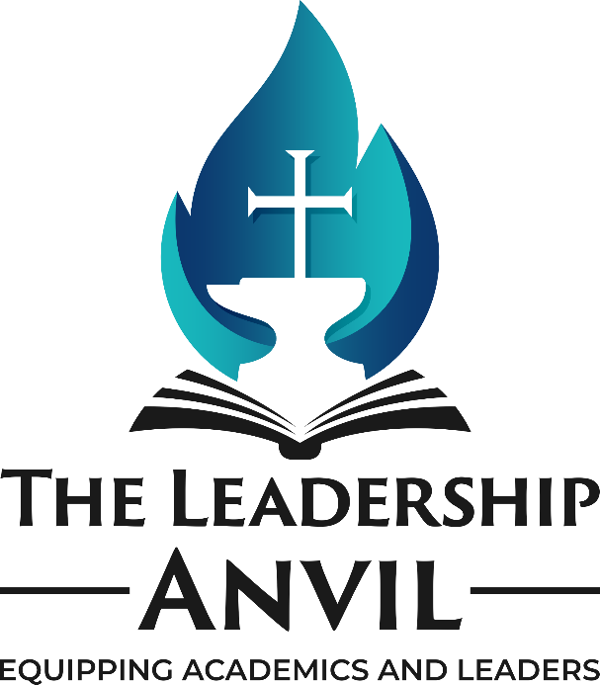
- Why are you requesting a scholarship?

- Which scholarship are you requesting? ___Individual ___Married Couple

